Ethan Myers

Introduction to Cloud Computing Spring 2021

Assignment 1

Get Familiar with Github as Source Code Repository for Upcoming Assignments

Task 1:

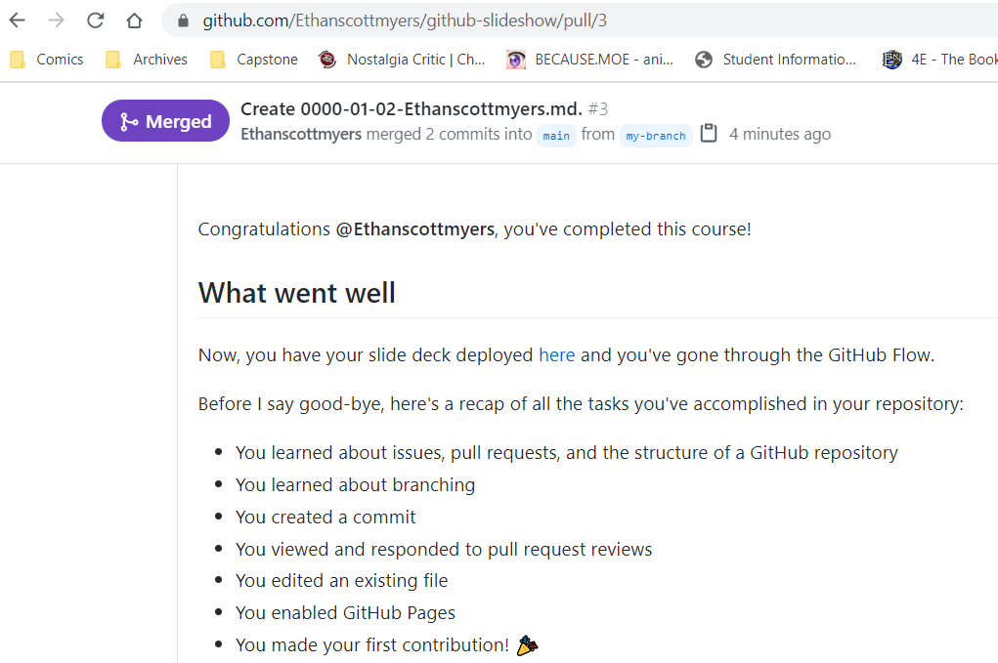

Task 2: